**ICP 5**

**Case : 1**

a. Optimizers : AdamOptimizer

b. Filter size : 3,4,5

c. Number of filters : 128

d. Dropout probability : 0.5

e. Batch size : 64

f. Number of epochs : 200

**Accuracy** and **loss** values

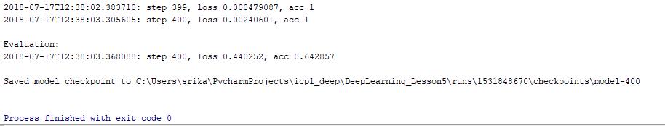

**Accuracy** Graph in Tensorboard

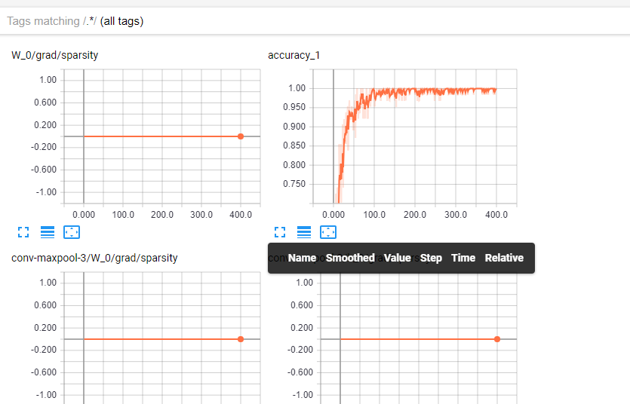

**Loss** Graph in Tensorboard

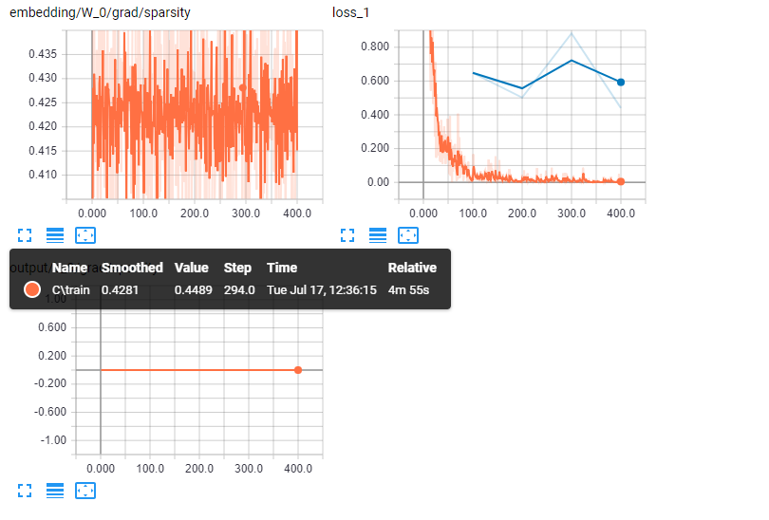

**Output** Graph in Tensorboard

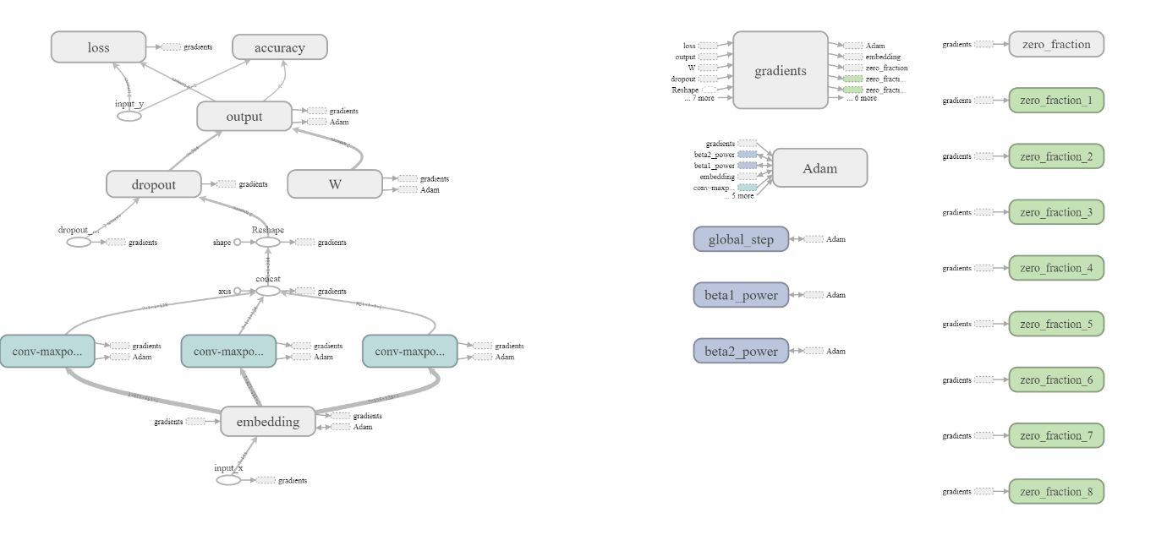

**Distribution** Graph in tenosrboard

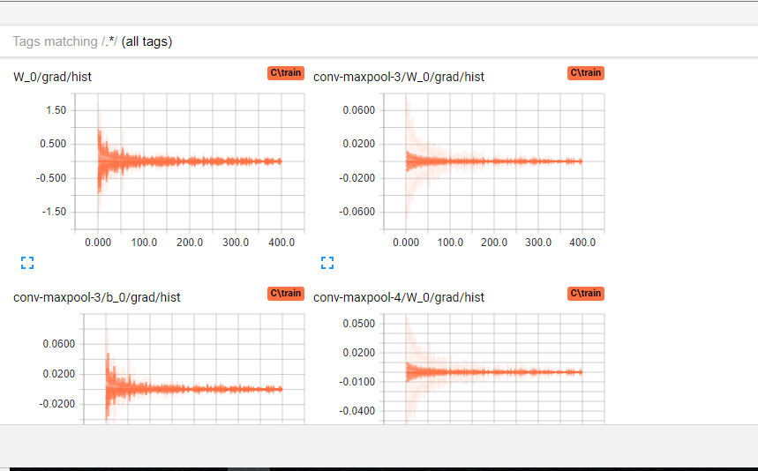

**Histogram** Graph in tenosrboard

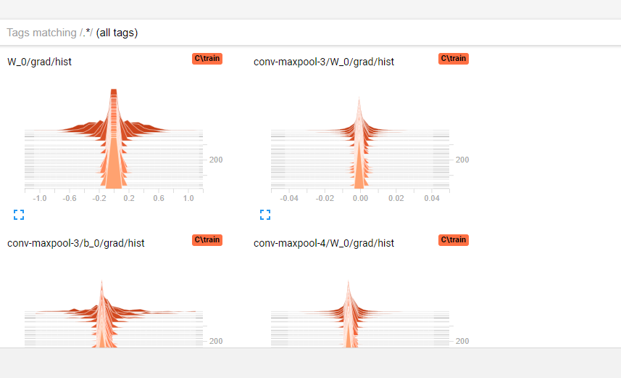

**Case : 2**

a. Optimizers : RMSPropOptimizer

b. Filter size : 1,2,3

c. Number of filters : 64

d. Dropout probability : 0.1

e. Batch size : 32

f. Number of epochs : 100

**Accuracy** and **loss** values

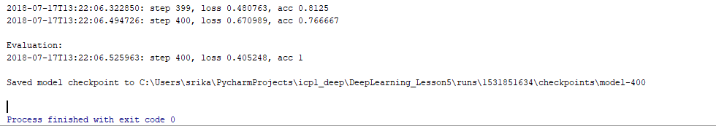

**Accuracy** Graph in Tensorboard

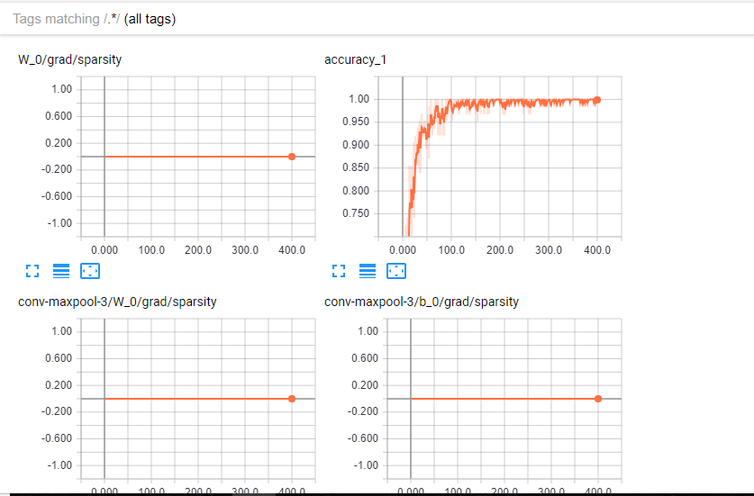

**Loss** Graph in Tensorboard

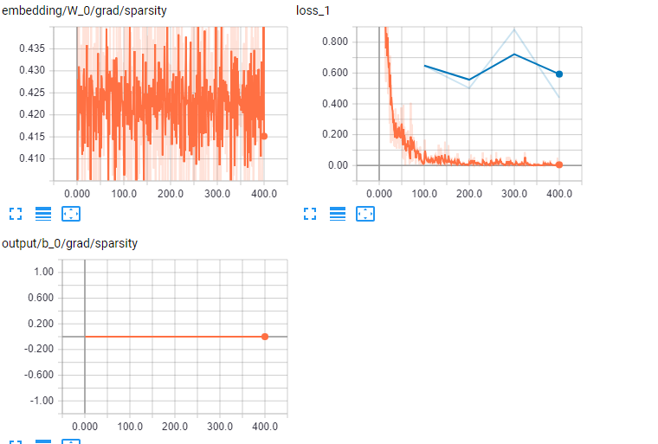

**Output** Graph in Tensorboard



**Case : 3**

a. Optimizers : GradientDescentOptimizer

b. Filter size : 4,5,6

c. Number of filters : 32

d. Dropout probability : 0.01

e. Batch size : 128

f. Number of epochs : 50

**Accuracy** and **loss** values

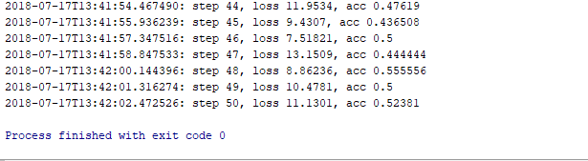

**Accuracy** Graph in tenosrboard

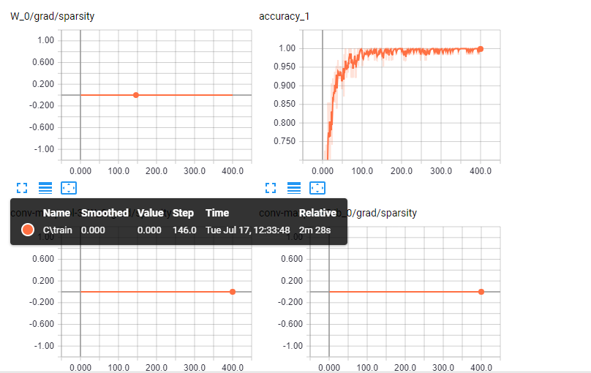

**Loss** Graph in tenosrboard

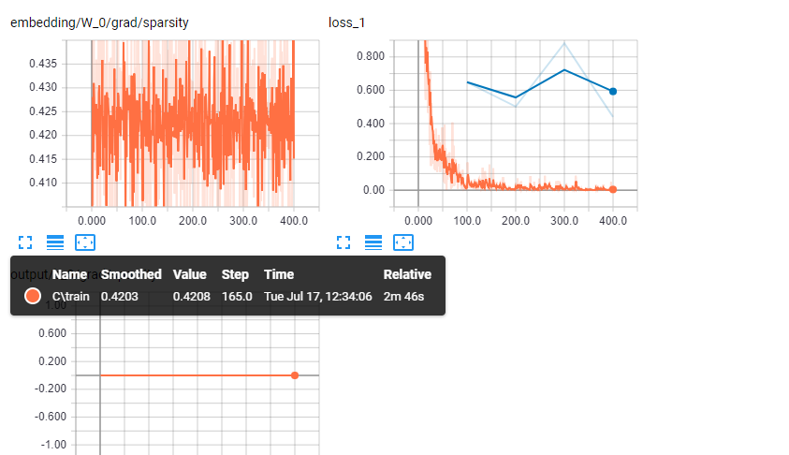

**Output** Graph in tenosrboard



**Conclusion :**

From the above observations and from few other observations, I can conclude that, for the RMSPropOptimizer I am getting the best results with less loss and more accuracy.